Weekly reports are to be emailed to atbecker@uh.edu by 5:00pm on Tuesdays. The purpose of a weekly report is to: (1) give you text and images for your papers, thesis, and dissertation, (2) document progress, (3) identify if you are stuck or need resources.

Weekly report

1. **My *Goals* from last week**

* Complete the modifications for the discrete motion demo and make a video for it.
* Make videos for the parts bin and some of the logic gates.

1. **My *Accomplishments* this week**
   1. Project 1: <Parts Bin Video>

* Youtube link to Parts Bin Video.

[*https://www.youtube.com/watch?v=SJwy1qdpw2s*](https://www.youtube.com/watch?v=SJwy1qdpw2s)

* In the video, four tetris pieces are assembled out of the red and blue magnetic sliders, it took about fifteen attempts to complete a good solid run on video. Once I had the footage it took me about thirty minutes to learn how to use the basics of the video editing program and another thirty minutes to make the necessary changes.

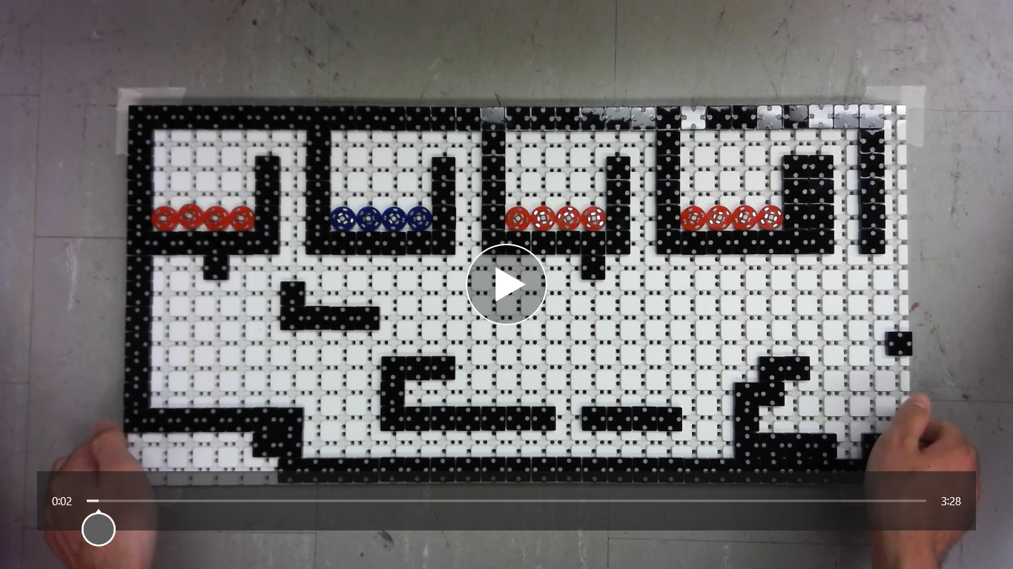

**Figure 1:** Screenshot of Parts Bin video.

* 1. Project 2: Carry Function Video
* The video is not quite complete yet, but it includes each of the six possible outcomes for the function and the process is completed autonomously with the tilt table stand. I am also going to make a video of the simple counter but only counting up to five as that is what fits on the small tilt table.

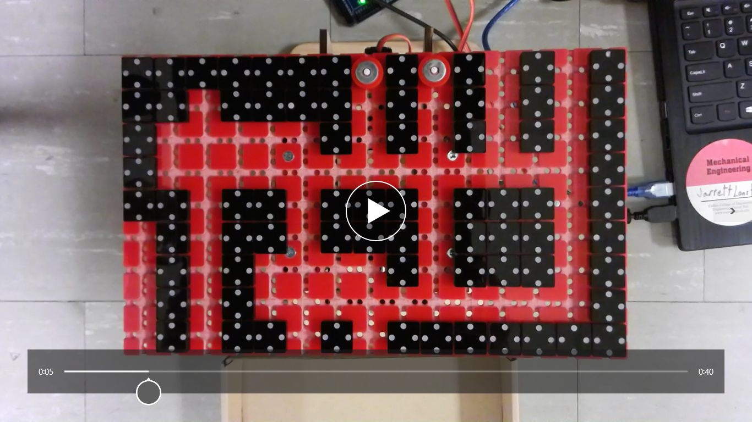

**Figure 2:** Screenshot of the Carry Function video.

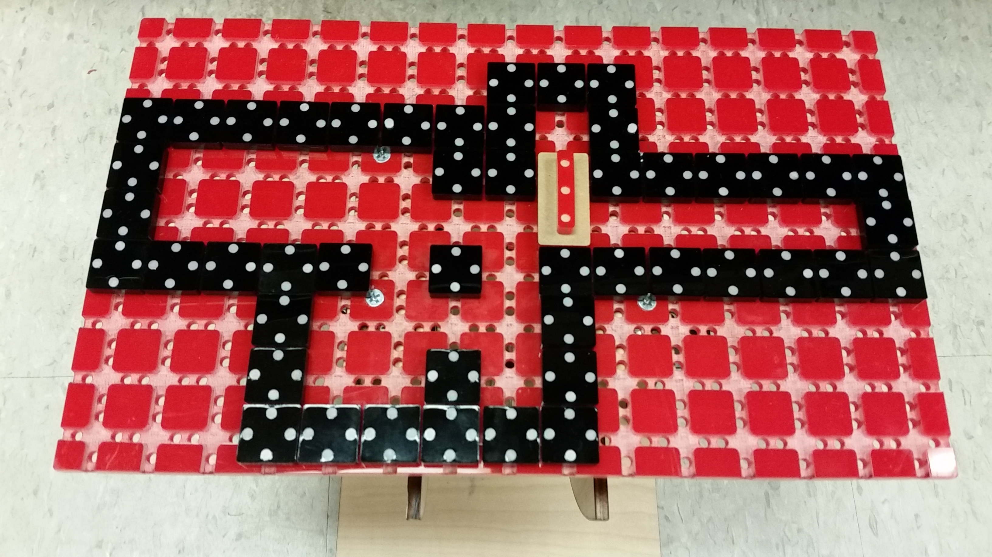

**Figure 3:** Simple Counter for five sliders setup on small tilt table.

* 1. Project 3: <Arun’s Discrete Motion Demo >
     + DWG file for the Discrete Motion Workspace.

<https://github.com/aabecker/LaserCutter3DPrinter/blob/master/LaserCutter/Designs/Jarrett%20Lonsford/clear_workspace_cover.dwg>

* + - After a great aha moment, Arun and I redesigned the workspace for the discrete motion demo so that there is a smooth piece of acrylic with a visible border that stops particles from moving parallel to the border. The particles are steel balls, and with some help from Victor they have a 3d printed shell around them to keep the particles properly spaced. The magnets that control the motion are still the same but now the particles glide smoothly and effortlessly across the workspace.

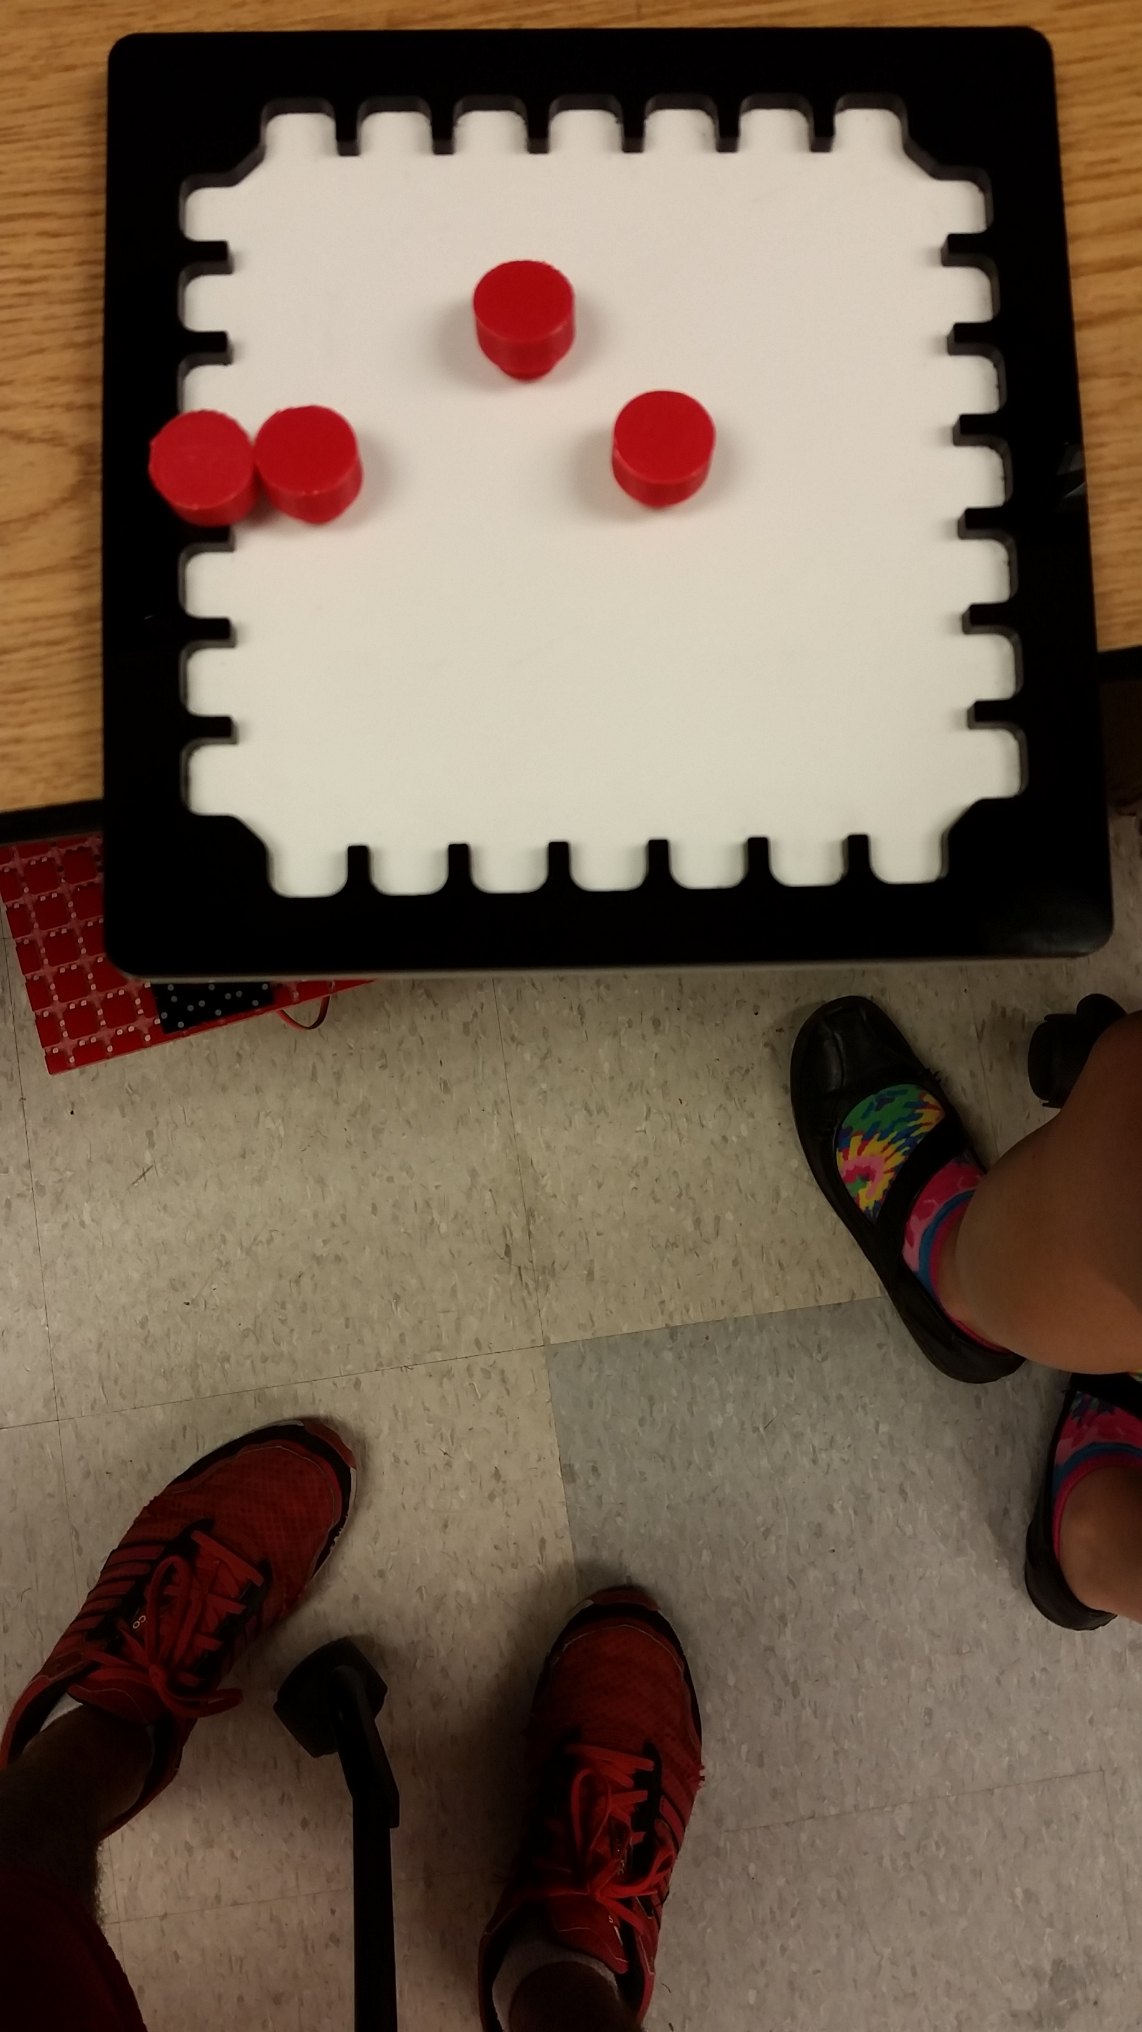

**Figure 4:** 8x8 workspace and “particles” that will be used for the discrete motion demo.

1. **My *Goals* for next week**

* Complete the video for the carry function.
* Make video for the simple counter.
* Determine what my most interesting design is and make a parts list and instructions for it.

1. **What I need Dr. Becker to do:**

Time Sheet: (Zoom in to read)



Notes: Week 10 I was moving out of my dorm and Week 11 I was on vacation from Tuesday through Sunday.